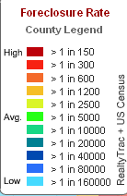
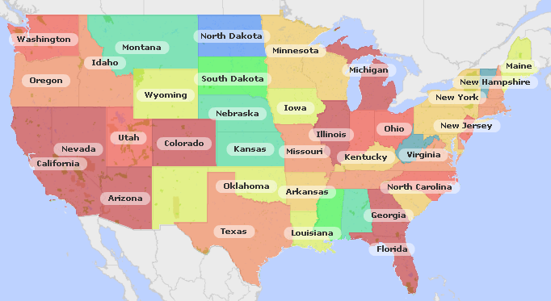
(http://hotpads.com, Foreclosure)

01 California, Florida, Arizona
02 Ohio
03 Texas
04 Kentucky
05 Wyoming
06 Mississippi
07 Kansas
08 Vermont
09 North Dakota

